**Property Vs Value**

CSS Property :

|  |  |
| --- | --- |
| PROPERTY | DESCRIPTION |
| [align-content](https://www.dofactory.com/css/align-content) | Aligns items in a flex container along flex lines. |
| [align-items](https://www.dofactory.com/css/align-items) | Aligns evenly spaced items in a flex container. |
| [align-self](https://www.dofactory.com/css/align-self) | Aligns an item inside a flex container. |
| [all](https://www.dofactory.com/css/all) | Resets all element properties to its default or inherited values. |
| [animation](https://www.dofactory.com/css/animation) | Creates an animating element. |
| [animation-delay](https://www.dofactory.com/css/animation-delay) | Sets a delay before an animation begins. |
| [animation-direction](https://www.dofactory.com/css/animation-direction) | Sets how, in which direction, an animation is played. |
| [animation-duration](https://www.dofactory.com/css/animation-duration) | Defines the duration of an animation cycle. |
| [animation-fill-mode](https://www.dofactory.com/css/animation-fill-mode) | Defines how styles are applied before and after animation. |
| [animation-iteration-count](https://www.dofactory.com/css/animation-iteration-count) | Sets the number of times an animation is played. |
| [animation-name](https://www.dofactory.com/css/animation-name) | Defines a name for the animation. |
| [animation-play-state](https://www.dofactory.com/css/animation-play-state) | Sets the animation play state to running or paused. |
| [animation-timing-function](https://www.dofactory.com/css/animation-timing-function) | Specifies the animation speed curve. |
| [backface-visibility](https://www.dofactory.com/css/backface-visibility) | Shows or hides the backface visibility of an element. |
| [background](https://www.dofactory.com/css/background) | Sets the background of an element. |
| [background-attachment](https://www.dofactory.com/css/background-attachment) | Defines how the background is attached to an element. |
| [background-blend-mode](https://www.dofactory.com/css/background-blend-mode) | Defines the background layer blending mode. |
| [background-clip](https://www.dofactory.com/css/background-clip) | Defines how background extends beyond the element. |
| [background-color](https://www.dofactory.com/css/background-color) | Sets the background color of the element. |
| [background-image](https://www.dofactory.com/css/background-image) | Specifies a background image for an element. |
| [background-origin](https://www.dofactory.com/css/background-origin) | Specifies the background image origin position. |
| [background-position](https://www.dofactory.com/css/background-position) | Sets the position of a background image. |
| [background-repeat](https://www.dofactory.com/css/background-repeat) | Specifies how the background image is repeated. |
| [background-size](https://www.dofactory.com/css/background-size) | Sets the size of the background image. |
| [border](https://www.dofactory.com/css/border) | Specifies a border for an element |
| [border-bottom](https://www.dofactory.com/css/border-bottom) | Specifies a bottom border for an element. |
| [border-bottom-color](https://www.dofactory.com/css/border-bottom-color) | Sets the color of a bottom border . |
| [border-bottom-left-radius](https://www.dofactory.com/css/border-bottom-left-radius) | Sets the border radius of the bottom left corner. |
| [border-bottom-right-radius](https://www.dofactory.com/css/border-bottom-right-radius) | Sets the border radius of the bottom right corner |
| [border-bottom-style](https://www.dofactory.com/css/border-bottom-style) | Sets the style of the bottom border. |
| [border-bottom-width](https://www.dofactory.com/css/border-bottom-width) | Sets the width of the bottom border |
| [border-collapse](https://www.dofactory.com/css/border-collapse) | Sets table borders to single collapsed line or separated. |
| [border-color](https://www.dofactory.com/css/border-color) | Sets the color of the border. |
| [border-image](https://www.dofactory.com/css/border-image) | Defines an image as border, instead of a color. |
| [border-image-outset](https://www.dofactory.com/css/border-image-outset) | Sets how far a border image extends beyond the border. |
| [border-image-repeat](https://www.dofactory.com/css/border-image-repeat) | Defines if and how the border image is repeated. |
| [border-image-slice](https://www.dofactory.com/css/border-image-slice) | Defines how the border image will be sliced. |
| [border-image-source](https://www.dofactory.com/css/border-image-source) | Specifies the url of the border image file. |
| [border-image-width](https://www.dofactory.com/css/border-image-width) | Sets the width of the image border. |
| [border-left](https://www.dofactory.com/css/border-left) | Sets the left border of the element. |
| [border-left-color](https://www.dofactory.com/css/border-left-color) | Sets the color of the left border. |
| [border-left-style](https://www.dofactory.com/css/border-left-style) | Sets the style of the left border. |
| [border-left-width](https://www.dofactory.com/css/border-left-width) | Sets the width of the left border. |
| [border-radius](https://www.dofactory.com/css/border-radius) | Sets the radius of the border. |
| [border-right](https://www.dofactory.com/css/border-right) | Sets the right border of the element. |
| [border-right-color](https://www.dofactory.com/css/border-right-color) | Sets the color of the right border. |
| [border-right-style](https://www.dofactory.com/css/border-right-style) | Sets the style of the right border. |
| [border-right-width](https://www.dofactory.com/css/border-right-width) | Sets the width of the right border. |
| [border-spacing](https://www.dofactory.com/css/border-spacing) | Sets the adjacent table cell distance. |
| [border-style](https://www.dofactory.com/css/border-style) | Defines the style of the border |
| [border-top](https://www.dofactory.com/css/border-top) | Sets the top border of the element. |
| [border-top-color](https://www.dofactory.com/css/border-top-color) | Sets the color of the top border. |
| [border-top-left-radius](https://www.dofactory.com/css/border-top-left-radius) | Sets the border radius of the top left corner. |
| [border-top-right-radius](https://www.dofactory.com/css/border-top-right-radius) | Sets the border radius of the top right corner. |
| [border-top-style](https://www.dofactory.com/css/border-top-style) | Sets the style of the top border. |
| [border-top-width](https://www.dofactory.com/css/border-top-width) | Sets the width of the top border. |
| [border-width](https://www.dofactory.com/css/border-width) | Sets the border width of the element. |
| [bottom](https://www.dofactory.com/css/bottom) | Positions the element from the bottom of the relative container. |
| [box-shadow](https://www.dofactory.com/css/box-shadow) | Adds a shadow effect to an element. |
| [box-sizing](https://www.dofactory.com/css/box-sizing) | Sets how element height and width are calculated. |
| [caption-side](https://www.dofactory.com/css/caption-side) | Defines on which side of the table a caption is placed. |
| [caret-color](https://www.dofactory.com/css/caret-color) | Sets the color of the blinking mouse caret. |
| [@charset](https://www.dofactory.com/css/charset) | Specifies the character encoding of the stylesheet. |
| [clear](https://www.dofactory.com/css/clear) | Sets the element side that does not allow floating elements. |
| [clip](https://www.dofactory.com/css/clip) | Sets how an image is cropped or clipped inside a container. |
| [clip-path](https://www.dofactory.com/css/clip-path) | Clips an element inside a specific shape or SVG. |
| [color](https://www.dofactory.com/css/color) | Specifies the color of text in an element. |
| [column-count](https://www.dofactory.com/css/column-count) | Divides an element into the specified number of columns. |
| [column-fill](https://www.dofactory.com/css/column-fill) | Specifies how divided columns are filled. |
| [column-gap](https://www.dofactory.com/css/column-gap) | Specifies the space between divided columns. |
| [column-rule](https://www.dofactory.com/css/column-rule) | Sets the style, width, and color of a column divider. |
| [column-rule-color](https://www.dofactory.com/css/column-rule-color) | Sets the color of a column divider. |
| [column-rule-style](https://www.dofactory.com/css/column-rule-style) | Sets the style of a column divider. |
| [column-rule-width](https://www.dofactory.com/css/column-rule-width) | Sets the width of a column divider. |
| [column-span](https://www.dofactory.com/css/column-span) | Sets number of divided columns an element should span. |
| [column-width](https://www.dofactory.com/css/column-width) | Specifies the width of a divided column. |
| [columns](https://www.dofactory.com/css/columns) | Divide an element into columns of a certain width. |
| [content](https://www.dofactory.com/css/content) | Used to insert content before or after an element. |
| [counter-increment](https://www.dofactory.com/css/counter-increment) | Increase or decrease a CSS counter. |
| [counter-reset](https://www.dofactory.com/css/counter-reset) | Initialize or reset CSS counter. |
| [cursor](https://www.dofactory.com/css/cursor) | Specifies the shape of the mouse cursor. |
| [direction](https://www.dofactory.com/css/direction) | Specifies the text writing direction of a block-level element. |
| [display](https://www.dofactory.com/css/display) | Specify an element's display behavior. |
| [empty-cells](https://www.dofactory.com/css/empty-cells) | Specifies whether empty table cell borders will be displayed. |
| [filter](https://www.dofactory.com/css/filter) | Adds an image enhancing effect to an image. |
| [flex](https://www.dofactory.com/css/flex) | Specifies the width of the flexible items. |
| [flex-basis](https://www.dofactory.com/css/flex-basis) | Specifies the initial width of a flex item. |
| [flex-direction](https://www.dofactory.com/css/flex-direction) | Specifies the direction for the flex item to align. |
| [flex-flow](https://www.dofactory.com/css/flex-flow) | Controls the direction and wrapping of flexible items. |
| [flex-grow](https://www.dofactory.com/css/flex-grow) | Specifies how a flex item can grow inside the container. |
| [flex-shrink](https://www.dofactory.com/css/flex-shrink) | Specifies how a flex item can shrink inside the container. |
| [flex-wrap](https://www.dofactory.com/css/flex-wrap) | Specifies how flexible items wrap inside the container. |
| [float](https://www.dofactory.com/css/float) | Sets how an element is positioned relative to other elements. |
| [font](https://www.dofactory.com/css/font) | Sets font family, variant, weight, height, and size for an element. |
| [@font-face](https://www.dofactory.com/css/font-face) | Embeds a custom font inside a web page |
| [font-family](https://www.dofactory.com/css/font-family) | Sets the font family for an element. |
| [font-kerning](https://www.dofactory.com/css/font-kerning) | Sets the spacing between the font's characters. |
| [font-size](https://www.dofactory.com/css/font-size) | Sets the size of the font for an element. |
| [font-size-adjust](https://www.dofactory.com/css/font-size-adjust) | Specifies a fall-back font size. |
| [font-stretch](https://www.dofactory.com/css/font-stretch) | Sets the text characters to a wider or narrower variant. |
| [font-style](https://www.dofactory.com/css/font-style) | Set the font style to normal, italic, or oblique. |
| [font-variant](https://www.dofactory.com/css/font-variant) | Specifies that text is displayed in a small-caps font. |
| [font-weight](https://www.dofactory.com/css/font-weight) | Sets the weight or thickness of the font. |
| [grid](https://www.dofactory.com/css/grid) | Defines a grid layout with responsive rows and columns. |
| [grid-area](https://www.dofactory.com/css/grid-area) | Sets the size and location of grid items in a grid container. |
| [grid-auto-columns](https://www.dofactory.com/css/grid-auto-columns) | Specifies the size of the columns in a grid container. |
| [grid-auto-flow](https://www.dofactory.com/css/grid-auto-flow) | Specifies the initial placement of items in a grid container. |
| [grid-auto-rows](https://www.dofactory.com/css/grid-auto-rows) | Specifies the initial size of the items in a grid container. |
| [grid-column](https://www.dofactory.com/css/grid-column) | Specifies the size and location of a grid item in a grid container. |
| [grid-column-end](https://www.dofactory.com/css/grid-column-end) | Specifies in which column-line the grid item will end. |
| [grid-column-gap](https://www.dofactory.com/css/grid-column-gap) | Specifies the gap size between columns in a grid container. |
| [grid-column-start](https://www.dofactory.com/css/grid-column-start) | Specifies in which column line the grid item will start. |
| [grid-gap](https://www.dofactory.com/css/grid-gap) | Specifies the gap size between grid rows and columns. |
| [grid-row](https://www.dofactory.com/css/grid-row) | Specifies the grid item size and location in a grid container. |
| [grid-row-end](https://www.dofactory.com/css/grid-row-end) | Specifies in which row-line the grid item will end. |
| [grid-row-gap](https://www.dofactory.com/css/grid-row-gap) | Specifies the gap size between rows in a grid container. |
| [grid-row-start](https://www.dofactory.com/css/grid-row-start) | Specifies in which row line the grid item will start |
| [grid-template](https://www.dofactory.com/css/grid-template) | Divides a page into sections with a size, position, and layer. |
| [grid-template-areas](https://www.dofactory.com/css/grid-template-areas) | Specifies area in a grid container. |
| [grid-template-columns](https://www.dofactory.com/css/grid-template-columns) | Sets the number and width of columns in a grid container. |
| [grid-template-rows](https://www.dofactory.com/css/grid-template-rows) | Sets the number and height of rows in a grid container. |
| [height](https://www.dofactory.com/css/height) | Sets the height of an element. |
| [hyphens](https://www.dofactory.com/css/hyphens) | Specifies hyphenation with wrap opportunities in a line of text. |
| [@import](https://www.dofactory.com/css/import) | Imports a style sheet inside another style sheet. |
| [justify-content](https://www.dofactory.com/css/justify-content) | Defines the alignment of items in a flex container. |
| [@keyframes](https://www.dofactory.com/css/keyframes) | Defines the CSS style to animate. |
| [left](https://www.dofactory.com/css/left) | Positions the element from the left of the relative container. |
| [letter-spacing](https://www.dofactory.com/css/letter-spacing) | Sets the spacing between characters. |
| [line-height](https://www.dofactory.com/css/line-height) | Sets the vertical spacing between lines of text. |
| [list-style](https://www.dofactory.com/css/list-style) | Defines the markers (bullet points) for items in a list. |
| [list-style-image](https://www.dofactory.com/css/list-style-image) | Defines an image markers (bullet points) for items in a list. |
| [list-style-position](https://www.dofactory.com/css/list-style-position) | Sets the marker (bullet point) positions for items in a list |
| [list-style-type](https://www.dofactory.com/css/list-style-type) | Defines the marker types (bullet points) for items in a list |
| [margin](https://www.dofactory.com/css/margin) | Sets the margin (outside spacing) for an element. |
| [margin-bottom](https://www.dofactory.com/css/margin-bottom) | Sets the bottom margin (outside spacing) for an element. |
| [margin-left](https://www.dofactory.com/css/margin-left) | Sets the left margin (outside spacing) for an element. |
| [margin-right](https://www.dofactory.com/css/margin-right) | Sets the right margin (outside spacing) for an element. |
| [margin-top](https://www.dofactory.com/css/margin-top) | Sets the top margin (outside spacing) for an element. |
| [max-height](https://www.dofactory.com/css/max-height) | Sets the maximumn height for an element. |
| [max-width](https://www.dofactory.com/css/max-width) | Sets the maximum width for an element. |
| [@media](https://www.dofactory.com/css/media) | Applies media queries to a page. |
| [min-height](https://www.dofactory.com/css/min-height) | Sets the minimum height for an element. |
| [min-width](https://www.dofactory.com/css/min-width) | Sets the minimum width for an element. |
| [object-fit](https://www.dofactory.com/css/object-fit) | Specifies how an image or video fits inside a container. |
| [object-position](https://www.dofactory.com/css/object-position) | Specifies the image or video position inside a container. |
| [opacity](https://www.dofactory.com/css/opacity) | Sets the opacity (transparency) of the element. |
| [order](https://www.dofactory.com/css/order) | Specifies the order of an item in a flex container. |
| [outline](https://www.dofactory.com/css/outline) | Adds an outline (highlighted border) to an element. |
| [outline-color](https://www.dofactory.com/css/outline-color) | Sets the color of an outline. |
| [outline-offset](https://www.dofactory.com/css/outline-offset) | Sets the space between the outline and border. |
| [outline-style](https://www.dofactory.com/css/outline-style) | Sets the style of an outline. |
| [outline-width](https://www.dofactory.com/css/outline-width) | Sets the width of an outline. |
| [overflow](https://www.dofactory.com/css/overflow) | Specifies the flow of content that exceeds the container. |
| [overflow-x](https://www.dofactory.com/css/overflow-x) | Specifies the flow of content that exceeds the container width. |
| [overflow-y](https://www.dofactory.com/css/overflow-y) | Specifies the flow of content that exceeds the container height. |
| [padding](https://www.dofactory.com/css/padding) | Sets the spacing between content and element border. |
| [padding-bottom](https://www.dofactory.com/css/padding-bottom) | Sets the spacing between content and bottom element border. |
| [padding-left](https://www.dofactory.com/css/padding-left) | Sets the spacing between content and left element border. |
| [padding-right](https://www.dofactory.com/css/padding-right) | Sets the spacing between content and right element border. |
| [padding-top](https://www.dofactory.com/css/padding-top) | Sets the spacing between content and top element border. |
| [page-break-after](https://www.dofactory.com/css/page-break-after) | Adds a print page-break after an element. |
| [page-break-before](https://www.dofactory.com/css/page-break-before) | Adds a print page-break before an element. |
| [page-break-inside](https://www.dofactory.com/css/page-break-inside) | Specifies if print page-break is allowed inside an element. |
| [perspective](https://www.dofactory.com/css/perspective) | Adds perspective to a 3D-positioned element. |
| [perspective-origin](https://www.dofactory.com/css/perspective-origin) | Sets the origin of the perspective for a 3D-positioned element. |
| [pointer-events](https://www.dofactory.com/css/pointer-events) | Specifies whether element reacts to pointer events or not. |
| [position](https://www.dofactory.com/css/position) | Sets the element's positioning method. |
| [quotes](https://www.dofactory.com/css/quotes) | Defines the quotation marks to be used on text. |
| [right](https://www.dofactory.com/css/right) | Positions the element from the right of the relative container. |
| [scroll-behavior](https://www.dofactory.com/css/scroll-behavior) | Specifies the scrolling behavior of an element |
| [table-layout](https://www.dofactory.com/css/table-layout) | Aligns elements according to a table with rows and columns. |
| [text-align](https://www.dofactory.com/css/text-align) | Sets the alignment of text inside an element. |
| [text-align-last](https://www.dofactory.com/css/text-align-last) | Sets the alignment for the last line of text. |
| [text-decoration](https://www.dofactory.com/css/text-decoration) | Defines the style and color of underlined text. |
| [text-decoration-color](https://www.dofactory.com/css/text-decoration-color) | Defines the color of underlined text. |
| [text-decoration-line](https://www.dofactory.com/css/text-decoration-line) | Defines the kind of line to use with text. |
| [text-decoration-style](https://www.dofactory.com/css/text-decoration-style) | Defines the style of underlined text. |
| [text-indent](https://www.dofactory.com/css/text-indent) | Sets the indentation to the beginning of text. |
| [text-justify](https://www.dofactory.com/css/text-justify) | Defines the text justification inside a container. |
| [text-overflow](https://www.dofactory.com/css/text-overflow) | Sets the display behavior of text that overflows a container. |
| [text-shadow](https://www.dofactory.com/css/text-shadow) | Adds a shadow effect to text. |
| [text-transform](https://www.dofactory.com/css/text-transform) | Defines text capitalization or casing. |
| [top](https://www.dofactory.com/css/top) | Positions the element from the top of the relative container |
| [transform](https://www.dofactory.com/css/transform) | Applies a 2D or 3D transformation to an element. |
| [transform-origin](https://www.dofactory.com/css/transform-origin) | Sets the origin for the transformation of the element. |
| [transform-style](https://www.dofactory.com/css/transform-style) | Specifies the display behavior of 3D space nested elements. |
| [transition](https://www.dofactory.com/css/transition) | Creates transitions from one property value to another. |
| [transition-delay](https://www.dofactory.com/css/transition-delay) | Creates a delay before the transition effect starts. |
| [transition-duration](https://www.dofactory.com/css/transition-duration) | Specifies the time the transition will take. |
| [transition-property](https://www.dofactory.com/css/transition-property) | Specifies the CSS property that will transition. |
| [transition-timing-function](https://www.dofactory.com/css/transition-timing-function) | Defines the speed curve function of the transition. |
| [user-select](https://www.dofactory.com/css/user-select) | Specifies how text can be selected (highlighted) |
| [vertical-align](https://www.dofactory.com/css/vertical-align) | Specifies vertical alignment of an element. |
| [visibility](https://www.dofactory.com/css/visibility) | Specifies the visibility of an element. |
| [white-space](https://www.dofactory.com/css/white-space) | Specifies how white-space is handled inside an element. |
| [width](https://www.dofactory.com/css/width) | Sets the width of an element. |
| [word-break](https://www.dofactory.com/css/word-break) | Specifies how line breaks take place. |
| [word-spacing](https://www.dofactory.com/css/word-spacing) | Sets the spacing between words. |
| [word-wrap](https://www.dofactory.com/css/word-wrap) | Specifies how long words can be wrapped. |
| [writing-mode](https://www.dofactory.com/css/writing-mode) | Sets the text reading orientation: top to bottom, etc. |
| [z-index](https://www.dofactory.com/css/z-index) | Sets the vertical stacking order relative to other elements. |

Html Value Attribute

For <button>, <input> and <option> elements, the value attribute specifies the initial value of the element.

For <li> elements, the value attribute sets the value of the list item (for ordered lists). The next list items will increment from that value.

For <meter> elements, the value attribute specifies the current value of the gauge.

For <progress> elements, the value attribute specifies how much of the task has been completed.

For <param> elements, the value attribute specifies the value of the parameter.

1.Button

<html>

    <body>

        <h1>HTML Attribute Value</h1>

        <h3>Button</h3><br>

        <form action="/action_page.php" method="get">

            Choose your State :

            <button name = "state" type="submit"Value="my_kerala">Kerala</button>

            <button name = "state" type="submit"Value="my_Tamilnadu">Tamilnadu</button>

        </form>

    </body>

</html>

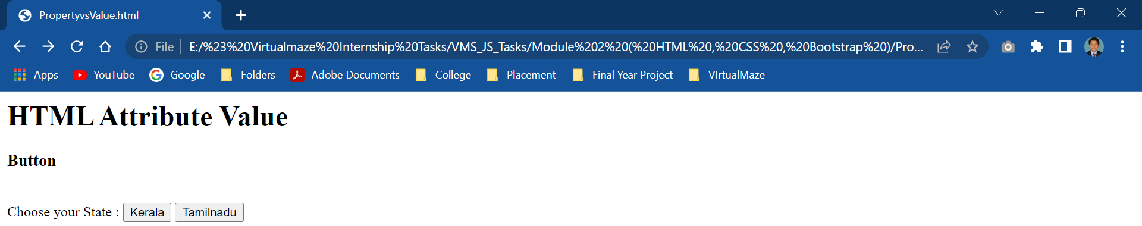

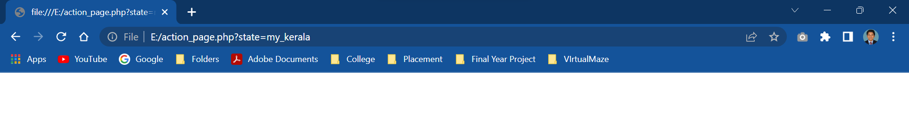

2.Input

<html>

<body>

    <h1>HTML Attribute Value</h1>

    <h3>input</h3><br>

<form action="/action_page.php">

  <label for="fname">First name:</label>

  <input type="text" id="fname" name="fname" value="Ravi"><br><br>

  <label for="lname">Last name:</label>

  <input type="text" id="lname" name="lname" value="Kumar"><br><br>

  <input type="submit" value="Submit">

</form>

</body>

</html>

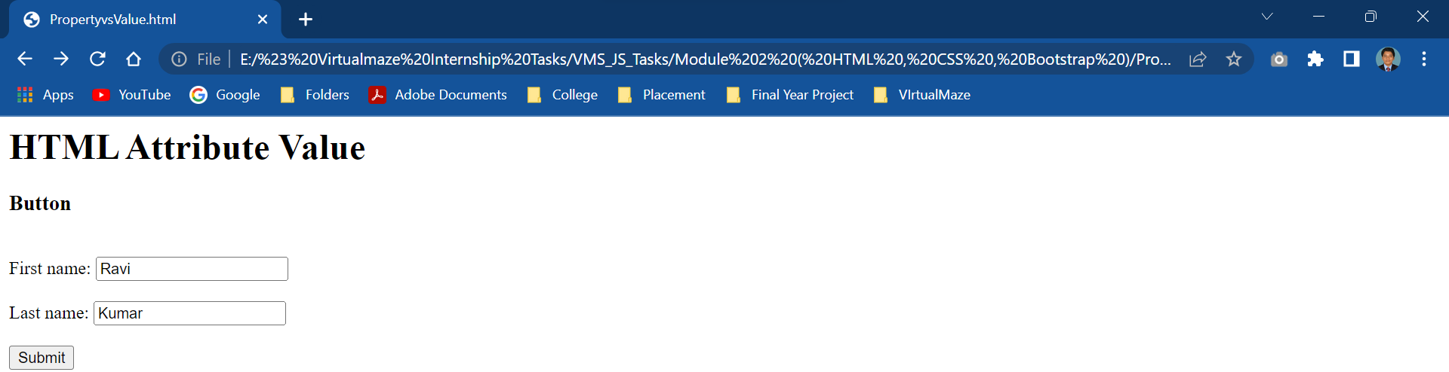

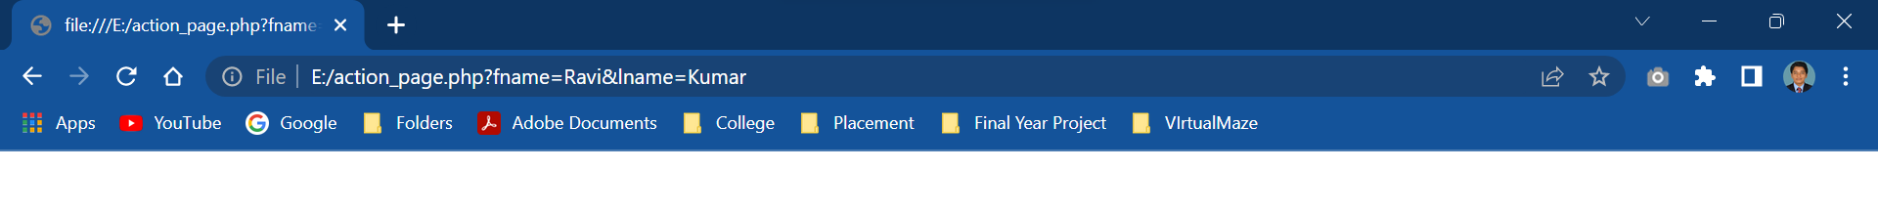

3.Li

<html>

<body>

    <h1>HTML Attribute Value</h1>

    <h3>li</h3><br>

<ol>

  <li value="75">Hyundai i20</li>

  <li>Swift</li>

  <li>Baleno</li>

  <li>Venue</li>

  <li>Skoda</li>

  <li>Verna</li>

</ol>

</body>

</html>

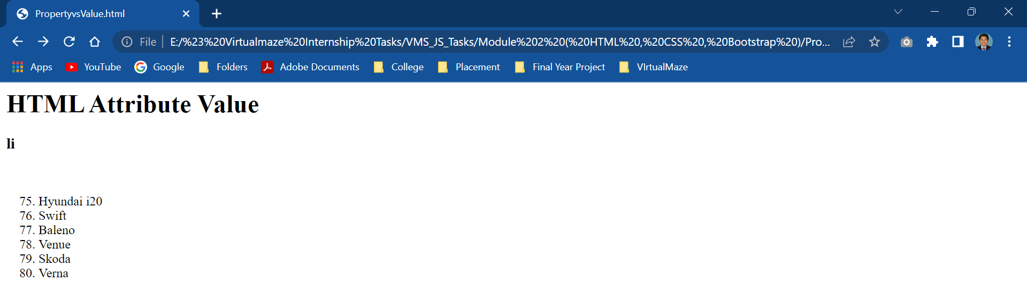

4.Meter

<html>

<body>

<h1>The meter high, low, max, min, and value attributes</h1>

<p><label for="anna">Anna's score:</label>

<meter id="anna" min="0" low="40" high="90" max="100" value="95"></meter></p>

<p><label for="peter">Peter's score:</label>

<meter id="peter" min="0" low="40" high="90" max="100" value="65"></meter></p>

<p><label for="linda">Linda's score:</label>

<meter id="linda" min="0" low="40" high="90" max="100" value="35"></meter></p>

<p>The high attribute specifies the range where the gauge's value is considered to be a high value.</p>

<p>The low attribute specifies the range where the gauge's value is considered to be a low value.</p>

<p>The max attribute specifies the upper bound of the gauge.</p>

<p>The min attribute specifies the lower bound of the gauge.</p>

<p>The value attribute specifies the current value of the gauge.</p>

</body>

</html>

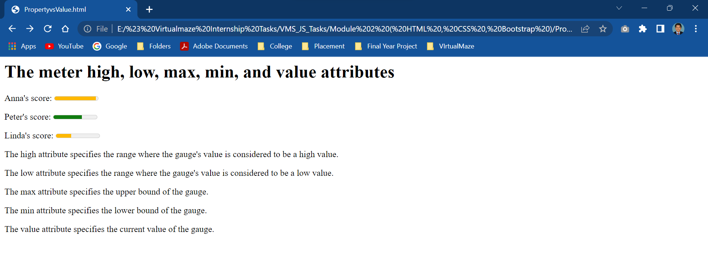

5.Option

<html>

<body>

    <h1>HTML Attribute Value</h1>

    <h3>Option</h3><br>

<form action="/action_page.php">

<label for="cars">Choose a car:</label>

<select id="cars" name="cars">

  <option value="verna">Verna</option>

  <option value="Swift">Swift</option>

  <option value="hyundaii20">Hyundai i20</option>

  <option value="skoda">Skoda</option>

</select>

<input type="submit" value="Submit">

</form>

<p>Choose a car, and click the "Submit" button to send input to the server.</p>

</body>

</html>

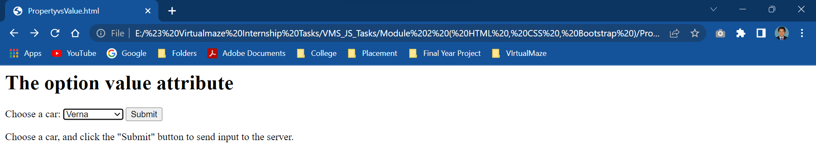

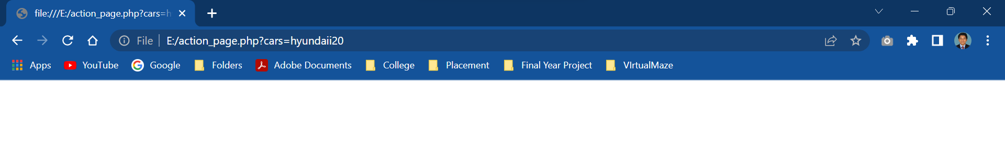

6.Progress

<html>

<body>

    <h1>HTML Attribute Value</h1>

    <h3>Progress</h3><br>

<label for="file">Downloading progress:</label>

<progress id="file" value="33" max="100"> 32% </progress>

</body>

</html>

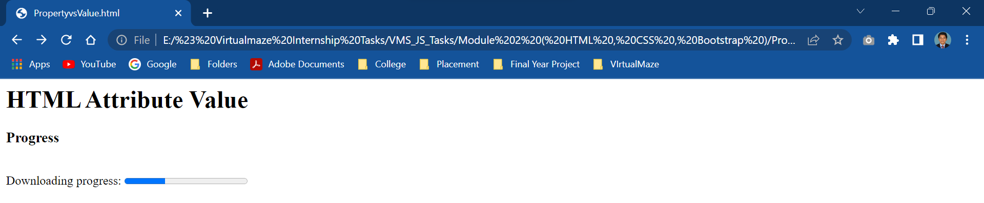

7.Param

<html>

<body>

    <h1>HTML Attribute Value</h1>

    <h3>Param</h3><br>

<object data="Adheeraa (mp3cut.net).mp3">

<param name="autoplay" value="true">

</object>

</body>

</html>

